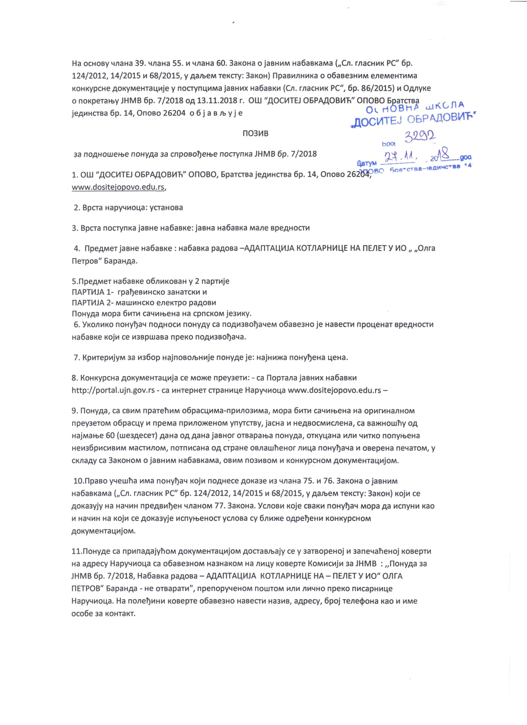
Ha OCHOBY H/iana 39. H/iana 55. M H/iana 60. SaKOHa o jaBHMM Ha6aBKaMa (,,Oi. r/iacHMK PC" 6p. 124/2012, 14/2015 M68/2015, y Aa/bCM reKcry: SSKOH) FlpaBM/iHMKa o o6aB63HMM KOHKypcHe AOKyMCHiauMJe y nocrynu,MMa JBBHMX Ha6aBKH (Cn. r/iacHMK PC", 6p. 86/2015) M

o noKperatty JHMB 6p. 7/2018 OA13.11.2018 r. OUJ "AOCMTEJ OBPAflOBMTi" OHOBO BparcrBa 6p. 14, OROBO 26204 o 6 j a B ^ y j e

F103MB

bOOt

3a noAHOLueH>e nonyAa 33 cnposoTjehbe nocryrwa JHMB 6p. 7/2018 rr± ^ 2 o _ _ g

- OUJ "AOCMTEJOBPAAOBMTi" OHOBO, BpaiCTBa jeAMHCTBa 6p. 14, OnoBO 262^®° www.dositeiopovo.edu.rs.

    - Bpcra HapyMMOi^a: ycraHoea

  - Bpcra nocTynKa jasne Ha6asKe: jasna Ha6aBK3

    - npeAMer jaBHe Ha6aBKe : Ha6aBKa paAOBa -AAARTAU.MJA KOT/1APHMLJ.E HA HE/1ETV MO „ ,, FleipoB"

Ha6aBKe o6/iMKOBaH y 2 naprnje

FIAPTMJA 1- rpatjeBMHCKO saHarcKM M

nAPTMJA 2- MaiuMHCKO e/ieKipo paAOBM

flOHyAa Mopa SMTM caMnn>eH3 Ha cpncKOM jesuKy.

  - YKO/IMKO noHyT)3M HOAHOCM nonyAy ca noAMSBotjaneM o6aB63HO je HaBecru Ha6aBKe KOJM ce Msepmssa npeKO n

  - KpmepMJyM sa M36op HajnoBO/bHkije nonyAe je: HaJHMwa noHytjeHa

- KoHKypcHa AOKyiweHramija ce wiome npeysein: - C3 riopia/ia jaBHMX Ha6aBKM http://portal.ujn.gov.rs - canHTepHer crpaHML^e Hapynnoua www.dositejopovo.edu.rs -

- rioHyAS, C3 CBUM nparefiuM o6paci^MMa-npn/io3MMa, Mopa 6nTM caHHHjCHa Ha

npeyseroM o6paci;y Mnpewia npn/io>KeHOM ynyrciBy, jacna MHeABOciwuc/ieHS, cs BamHoiutiy OA HajM3H>e 60 (wesAecer) Aana OAA3H3 jsBHor oiB3paH>a noHyAa, OTKyi^ana w\v\ HMTKO nonyhteHa Hen36pMCMBHM MacTM/ioM, noTnncaH3 OA CTpaHB OB/iaiutieHor i\v(u,a noHyfjaHa MosepeHa neMaroiw, y

CK/13AY Ca 33KOHOM O jaBHMM Ha6aBK3Ma, OBMM nOSMBOM M KOHKypCHOM AOKyiV\eHTa4MJOM.

lO.npaBO yneiuTia Miwa noHytjan KOJM noAHece AOKase us M/iana 75. M76. 3a«OHa

Ha6aBK3M3 (,,Cn. r/iacHMK PC" 6p. 124/2012, 14/2015 M 68/2015, y p,an>eM reKcry: SBKOH) KOJM ce AOKssyjy Ha HSMMH npeABnTjeH H/iaHOM 77. SSKOHS. YC/IOBM Koje CBBKM nonytjaM wiopa Aa McnyHM Kao
M H3HMH H3 KOJM C6 AOK33yje MCnyH>eHOCT yC/lOB3 Cy 6^M>K6 OApef)6HM KOHKypCHOM

ca npMnaA3JyriOM AOKyM6HT3i4MjoM Aocrasybajy ce y ssrsopeHOJ MssnensTieHoj KOBCPTH MB aApecy HapynMoua cs o6aee3HOM HSSHSKOM HS /iMi;y Kosepre KOMMCMJM sa JHMB : ,,noHyAa 33 JHMB 6p. 7/2018, Ha6aBKa paAOBa - AAAnTAU,MJA KOT/1APHMU.E HA- HE/1ETY MO" 0/1FA nETPOB" BapaHAa- He oiBaparM", npenopyneHOM ROUJTOM M/IM ^MHHO npeKO nMcapHMu,e HapyHMOua. Ha no^eTjMHM Kosepie o6aB63HO HaBecru HSSMB, 3Apecy, 6poj re/iecjioHa Kao MMMB

OC06e 33 KOHT3KT.

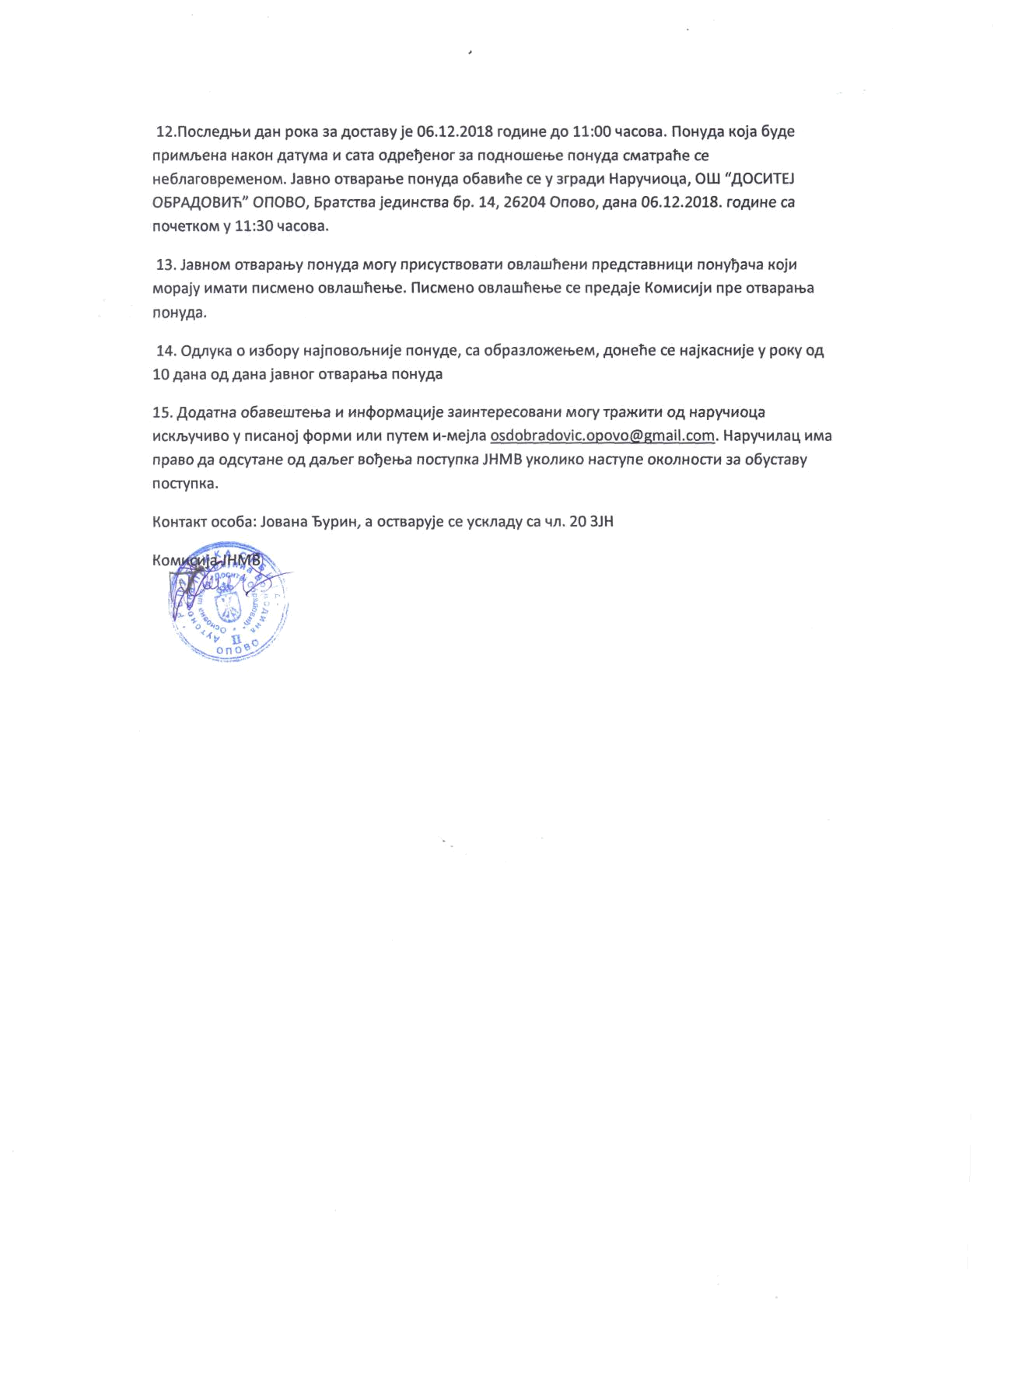
12.nocneAH3M Aan pOKa 33 Aocrasy je 06.12.2018 roAMHe AO 11:00 Macosa. PloHyAa Koja 6yAe npMM/beHa HaKOH Aaryiwa M cars OApefjenor sa noAHOiueH>e nonyAa cMarpahe ce He6/iaroBpeMeHOM. Jasno OTBapaHae nonyAa oGasuhe ce y srpaAH HapyHMOija, OUJ "flOCMTEJ OBPAflOBHTi" OPOBO, BparcTBa jeAUHCTBa 6p. 14, 26204 OnoBO, Aana 06.12.2018. roAMHe ca
11:30

- JaBHOM OTBapatty noHyAa Mory npucycTBOBarn oB^aujheHM npeAcraBHML\M noHyljaMa KOJM Mopajy niwa™ nucMBHO OB/iamheHje. FlMCMeHO oB/iaujtieHae ce npeAaje KOMMCMJM npe oTBapan>a

- OA/iyKa o M36opy Hajnoao/bHuje nonyAe, ca o6pa3^omeH>eM, AOHeTie ce HajKacHMje y ponyOA 10 A3H3 OA A^na JaBHOr OTBapan>a

15. flOAaina o63BeujTeH>a MMH(J)opMaHMJe sanHTepecosaHM Mory rpamMTM OA

MCK/byHMBO y nMcaHOj (J)opMM n/iM nyTeM n-M6j/ia osdobradovic.opovo@gmail.com. HspyMM/iai; npaso Aa OACyTSHe OA f&Jber Botjett>a nocrynKa JHMB YKO^MKO Hacryne OKO^HOCTM 33 o6ycraBy nocrynKa.

KOHTSKT oco6a: Josana "BypMH, a ocrBapyje ce ycK/iaAV ^{ca} H/I. 20 3JH

